## Resizing using Control Points

Most of the RapidPlan objects can be resized by moving their control points. Moving the control points changes the shape of the object, rather than just stretching or shrinking it.

**To resize with control points:**

* Select the item you wish to resize.
* Drag its control points until the object is the size and shape you require.
* 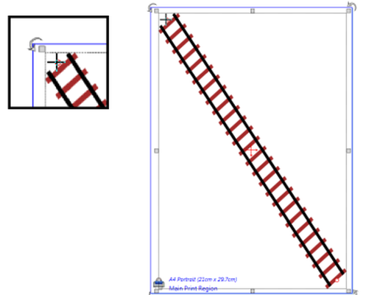
* Control_Point_resize
* **Note**: The cursor has changed as it hovers over the control point. This means it is ready to move the control point.